Case Study
Profile of M/s Deccan Pulverizers Private Limited

Name of the Enterprise | M/s Deccan Pulverizers Private Limited
Udyog Aadhar | 352884121771
GST | 36AAECD5811D1Z1
Line of Activity | Manufacturing of Silica/potash powder from quartz/feldspar mineral stones.
Factory Address | SY.No.267, Talakondapally Village & Mandal, Mahabubnagar District, 509321.
Registered Office Address | Flat No- 201, 2-2-3/B/4, c-57, DD Colony, Hyderabad Telangana -500007
Established | 2013
Constitution | Private Limited Company
Managing Director | Tarun Reddy Ambati
Primary Lender | APSFC

Who suggested TIHCL? or Reference
Principal Secretary, Industries & Commerce Department, Government of Telangana has referred the unit to TIHCL for revival assistance

Brief History and Problems encountered by the entrepreneur
M/s. Deccan Pulverizers Private Limited is promoted by Ch.Samyuktha, Mrs. A.Vanaja (Director), Mr.A.Tarun (Managing Director). The firm is engaged in manufacturing mineral powder from quartz/feldspar mineral stones. The final product is used as raw material in ceramic, glass, paint & electrical industries.
In the planning phase of the business promoter expected huge export orders. The firm has availed a Term Loan of ₹6.2 million for constructing the factory shed and purchasing machinery. The firm has purchased machinery as proposed in Detailed Project Report and there was no formal working capital arrangement. The unit has incentives sanctioned by State Government aggregating to ₹ 2.1 million including investment subsidy of ₹1.00 million which are awaiting disbursement.
The machinery was ordered as soon as the SFC sanctioned the loan, but the installation of machinery was delayed from vendors end. The business didn’t receive expected export orders and the promoter searched for buyers in the local markets. In initial stages couldn’t find an appropriate buyer who can pay in 60 days due to which, the receivables were delayed and the payments to the SFC were also delayed. SFC started charging penal interest for the delayed payments.
In the meantime, the constructed factory shed was damaged due to heavy rains and cyclone, the entrepreneur repaired the shed from his own funds. The project was not feasible with one machinery as the margins were too low in the local markets the promoter has installed a second machinery with his own funds and increased the unit’s production capacity. The promoter has gradually improved his sales in the local markets now he receives orders from M/s Visaka Industries AA+ care rating company, it purchases entire production of the company.
Meanwhile, due to irregularities in the repayment, SFC has issued demand notice on 6th September 2019 asking the unit to pay overdue interest and instalments amounting to ₹ 20 lacs by 1st October 2019, failing which they will take further steps like legal action etc., The promoter and the company were in the great stress as it shattered their goals and dreams. With a sword on his neck, unable to secure alternate funds with his collateral locked up with SFC threatened for sale in the worst scenario, he approached the TIHCL for resolution.
TIHCL after due discussions with the SFC and ascertaining its preparedness for revival, started the diagnostic exercise.
- Line of activity
Entrepreneur engaged in Manufacturing of Silica/potash powder from quartz/feldspar mineral stones. The final product is used as raw material in ceramic, glass, paint & electrical industries
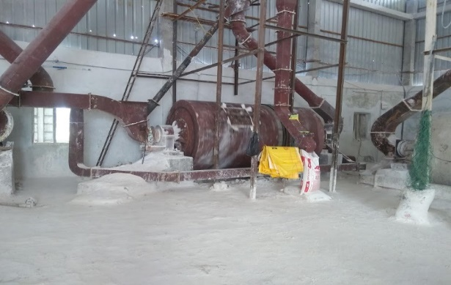

- Location of the unit
The unit is located at SY.No.267, Talakondapally Village & Mandal, erstwhile Mahabubnagar District, now it comes under Ranga Reddy District 509321. The unit location has abundance of raw material available.

- Machinery/ Manufacturing Process
The firm is engaged in manufacturing mineral powder from quartz/feldspar mineral stones by ball mill technology. The unit has two machines to ground the mineral rocks to final product and one automated carrier belt to dump the final product into containers for transportation. The company purchases input material from M/s. Venkateswara Enterprises (raw material); M/s. Ramakrishna Enterprises (packing bags).
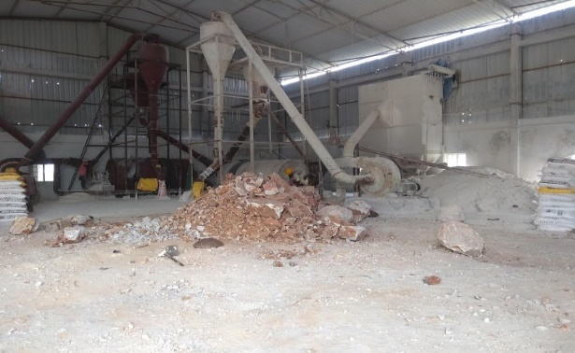

- Managerial Competencies, Family Details and their impact on business:
Mr. Tarun Reddy Ambati, Managing Director of the Unit displayed high involvement in the project as this being his primary source of income. He is first generation entrepreneur with good academic background and he has got knowledge of the Manufacturing activity and run the activity with the help of his skilled staff.
The company is promoted by Ch.Samyuktha, his sister and the other director Mrs. A.Vanaja is his mother. His family supports him to run his business successfully. There is a positive impact of his family on his business as the family members were consciously supported him in infusion of owner’s capital whenever company required during the establishment and running of the unit

- Inspiration for starting enterprise:
Entrepreneur Ambati Tarun Reddy is a graduate in automobile engineering form Melbourne University, Australia. He returned back to India with great goal of setting up an enterprise and creating employment in his hometown. He started the company with the support of all his family members.

- Primary Lenders Financial Support and why was it preferred?
The entrepreneur first approached APSFC for the financial support in setting up his business unit. The entrepreneur is sound in technical knowledge but not aware of banking and financial institutions he went by a known Chartered Account advice.

- Time Line for availing the credit
The loan was released progressively over a period of time as per the requirement proposed in detailed project report. There was no delay from primary lender’s end. The total amount of ₹6.2 million was released in 6 months progressively after the date of sanction.

- Market for Business
The complete production of the company is supplied to M/s Visaka Industries, an AA plus Care ratings buyer, the company consumption of the product is huge.
The customer has Hyderabad Industries as other backup option.

- Details of other loans
The entrepreneur has infused money by taking hand loans from very close family members. Apart from family loans there are no other loans taken.

- Response and support from TIHCL

Client has approached TIHCL for priority release of sanctioned incentives for the revival of the unit. The unit was banking with SFC, Mahabubnagar Branch. The unit was sanctioned Term loan of ₹ 6.20 million by SFC in 2014. There is no formal working capital arrangement. The unit has fallen sick due to high fixed expenses in the initial years of commencement of business.
TIHCL has diagnosed the enterprise and identified following reasons of sickness
- Delay in machinery supply and installation
- The unit at its initial stages couldn’t find a appropriate buyer who can pay in 60 days due to this the receivables were delayed and the payments to the term lender has delayed.
- Natural Calamity damaged factory shed
- The project was not feasible with one machinery as the margins are too low the customer has anticipated this and installed a second machinery with his own funds and made the unit viable after a year of commencement of production
- High cost of borrowed funds and penal interest charged by term lender

- How TIHCL addressed the concerns
As per the TIHCL resolution package, Critical Amount Funding (CAF) loan is required to regularize the account of SFC. SFC charges 17% interest rate p.a. and provides 2% as interest rebate for prompt and timely payment. SFC levies 2% as penal interest for irregularities in the payment. With TIHCL’s CAF loan this interest burden will be reduced by 2-4%p.a. on term loan of ₹6.2 million. High interest rate is one of the reasons for the stress experienced by the unit.

We have sent the recommendations based on our viability report to Industries Department, Government of Telangana for priority release of sanctioned incentives.

With CAF loan the account gets regularized and stops SFC from taken any actions as mentioned in demand notice issued to the entrepreneur.

Labour Status (Post TIHCL Intervention)
Gender | Skilled | Unskilled
Men | 04 | 17
Women | 0 | 0
Total | 04 | 17

Livelihood: At 90% of the capacity they have employed 21 workers and their families are dependent on this enterprise which is around 105 individuals. The employed workers are sufficient to run at full capacity; the idle time of workers will be reduced.

- Confidence on TIHCL

The entrepreneur cherishes in association with TIHCL. After TIHCL intervention unit is running at its maximum capacity. The entrepreneur’s loan repayment is on time.

